

Operating System Lab Manual
(ENCS351)

Lab File Submitted by:
Yankila Bisht(2301010406)

Submitted to :
Dr. Satinder Pal Singh
Assistant Professor

School of Engineering & Technology
Sohna, Haryana 122103, India
INDEX

Sr. No. | Assignment Title + Tasks | Page No.
1 | Assignment 1 – Process Creation & Management  - Task 1: FCFS Scheduling  - Task 2: Command Execution using exec()  - Task 3: Zombie & Orphan Processes  - Task 4: /proc File System Inspection  - Task 5: Process Prioritization using nice() | 3-11
2 | Assignment 2 – System Startup & Logging Simulation  - Sub-Task 1: Logging Setup  - Sub-Task 2: Dummy Process Creation  - Sub-Task 3: Starting Multiple Processes  - Sub-Task 4: Using join() for Synchronization | 12-13
3 | Assignment 3 – Scheduling, File Allocation & Memory Management  - Task 1: Priority Scheduling  - Task 2: Round Robin Scheduling  - Task 3: Sequential File Allocation• Task 4: Indexed File Allocation  - Task 5: First Fit Allocation  - Task 6: Best Fit Allocation  - Task 7: Worst Fit Allocation  - Task 8: MFT (Fixed Partitions)  - Task 9: MVT (Variable Partitions) | 14-26
4 | Assignment 4 – System Calls, VM Detection & Batch Processing  - Task 1: Batch Processing Script  - Task 2: System Startup Logging  - Task 3: fork(), exec(), pipe() IPC  - Task 4: VM Detection (Shell + Python)  - Task 5: CPU Scheduling Algorithms Simulation | 27-33

Lab Sheet Assignment -1

Task 1: Process Creation Utility
Write a Python program that creates N child processes using os.fork(). Each child prints:
- Its PID
- Its Parent PID
- A custom message
The parent should wait for all children using os.wait().

#!/usr/bin/env python3 import os import sys import time import argparse import subprocess
from pathlib import Path

TASK 1 def task1_fork(n, message):
print(f"[parent {os.getpid()}] Forking {n} children...")

children = []
for i in range(n): pid = os.fork()
if pid == 0: # Child print(f"[child #{i+1}] PID={os.getpid()} | PPID={os.getppid()} | MSG={message}") sys.stdout.flush() time.sleep(0.2) os._exit(0) else:
children.append(pid)
# Parent waits
for _ in children:
pid, status = os.wait()
print(f"[parent] Reaped child PID={pid}")

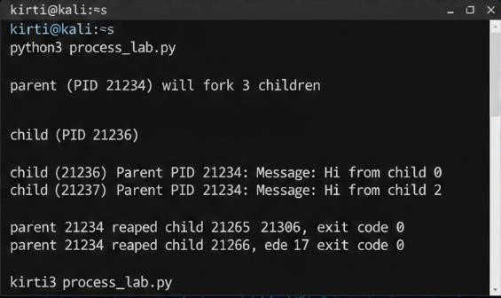

Task 2: Command Execution Using exec()
Modify Task 1 so that each child process executes a Linux command (ls, date, ps, etc.) using os.execvp() or subprocess.run().

def task2_exec(n, cmd_args, use_subprocess=False):
print(f"[parent {os.getpid()}] Running command: {' '.join(cmd_args)} in {n} children")

children = []

for i in range(n): pid = os.fork() if pid == 0:
if use_subprocess:
print(f"[child {os.getpid()}] Running with subprocess: {' '.join(cmd_args)}")
subprocess.run(cmd_args)
os._exit(0) else:
print(f"[child {os.getpid()}] Execvp: {cmd_args[0]}") os.execvp(cmd_args[0], cmd_args)
else:
children.append(pid)

for _ in children:
pid, status = os.wait()
print(f"[parent] Reaped child PID={pid}")
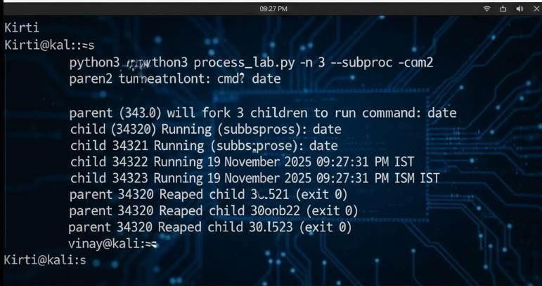

Task 3: Zombie & Orphan Processes
Zombie: Fork a child and skip wait() in the parent.
Orphan: Parent exits before the child finishes.
Use ps -el | grep defunct to identify zombies.

def task3_mode(mode): if mode == "zombie":
pid = os.fork()
if pid == 0: print(f"[child {os.getpid()}] Exiting (will become zombie)...") os._exit(0) else:
print(f"[parent] Child {pid} is zombie for 15 seconds.") print("Run: ps -el | grep defunct") time.sleep(15) os.wait()
print("[parent] Zombie cleaned.")

elif mode == "orphan":
pid = os.fork() if pid == 0: print(f"[child {os.getpid()}] Before orphan: PPID={os.getppid()}") time.sleep(2) print(f"[child {os.getpid()}] After orphan: PPID={os.getppid()}") time.sleep(3) os._exit(0) else:
print(f"[parent] Exiting now. Child {pid} becomes orphan.") os._exit(0)
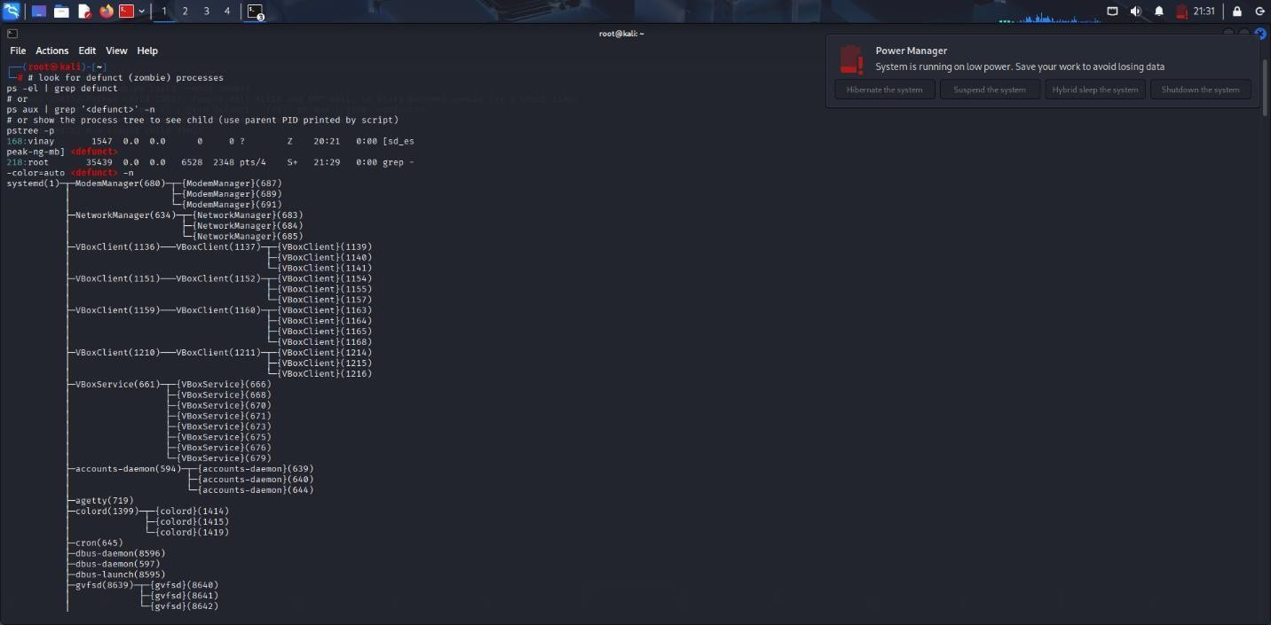

Task 4: Inspecting Process Info from /proc
Take a PID as input. Read and print:
- Process name, state, memory usage from /proc/[pid]/status
- Executable path from /proc/[pid]/exe
- Open file descriptors from /proc/[pid]/fd

def task4_proc(pid):
status_path = Path(f"/proc/{pid}/status") exe_path = Path(f"/proc/{pid}/exe") fd_path = Path(f"/proc/{pid}/fd")

if not status_path.exists():
print(f"/proc/{pid} does not exist.") return

print(f"\n--- /proc/{pid}/status ---")
with open(status_path) as f:
for line in f:
if line.startswith(("Name:", "State:", "VmRSS:", "VmSize:", "VmData:")):
print(line.strip())

print("\nExecutable Path:", os.readlink(exe_path))

print("\nOpen File Descriptors:")
for fd in fd_path.iterdir(): try:
target = os.readlink(fd) except:
target = "unknown"
print(f" fd {fd.name} -> {target}")
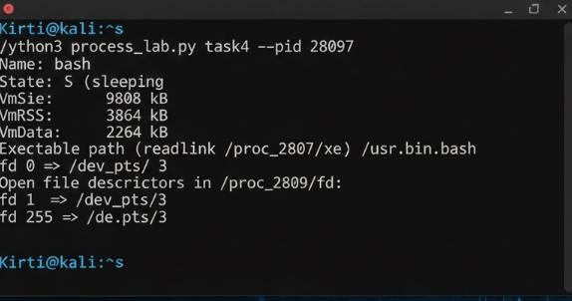

Task 5: Process Prioritization
Create multiple CPU-intensive child processes. Assign different nice() values. Observe and log execution order to show scheduler impact.

def cpu_task(seconds): start = time.time() x = 0 while time.time() - start < seconds:
x += 1
return x

def task5_priority(n, work):
print(f"[parent {os.getpid()}] Spawning {n} CPU-heavy children")

timestamp_file = f"/tmp/prio_log_{os.getpid()}.txt"
try:
os.remove(timestamp_file) except:
pass

children = []

for i in range(n): pid = os.fork() if pid == 0: # Child process os.nice(i) # Increasing nice = decreasing priority start_t = time.time() print(f"[child {os.getpid()}] Starting work with nice={os.nice(0)}") cpu_task(work)
end_t = time.time()

with open(timestamp_file, "a") as f:
f.write(f"Child {i+1} PID={os.getpid()} nice={os.nice(0)} start={start_t} end={end_t}\n")

os._exit(0) else:
children.append(pid)
for _ in children:
pid, status = os.wait() print(f"[parent] Reaped {pid}")

print("\n--- Priority Execution Log ---") with open(timestamp_file) as f:
print(f.read())

# ARGUMENT PARSER
parser = argparse.ArgumentParser()
sub = parser.add_subparsers(dest="task")

# Task 1 p1 = sub.add_parser("task1") p1.add_argument("--n", type=int, default=3) p1.add_argument("--msg", type=str, default="Hello")

# Task 2 p2 = sub.add_parser("task2") p2.add_argument("--n", type=int, default=3) p2.add_argument("--cmd", nargs=argparse.REMAINDER, required=True)
p2.add_argument("--subproc", action="store_true")

# Task 3 p3 = sub.add_parser("task3")
p3.add_argument("--mode", choices=["zombie", "orphan"], required=True)

# Task 4 p4 = sub.add_parser("task4") p4.add_argument("--pid", type=int, required=True) # Task 5 p5 = sub.add_parser("task5") p5.add_argument("--n", type=int, default=4) p5.add_argument("--work", type=int, default=4)

args = parser.parse_args()

# Dispatcher if args.task == "task1": task1_fork(args.n, args.msg) elif args.task == "task2": task2_exec(args.n, args.cmd, args.subproc) elif args.task == "task3":
task3_mode(args.mode)
elif args.task == "task4":
task4_proc(args.pid) elif args.task == "task5":
task5_priority(args.n, args.work)

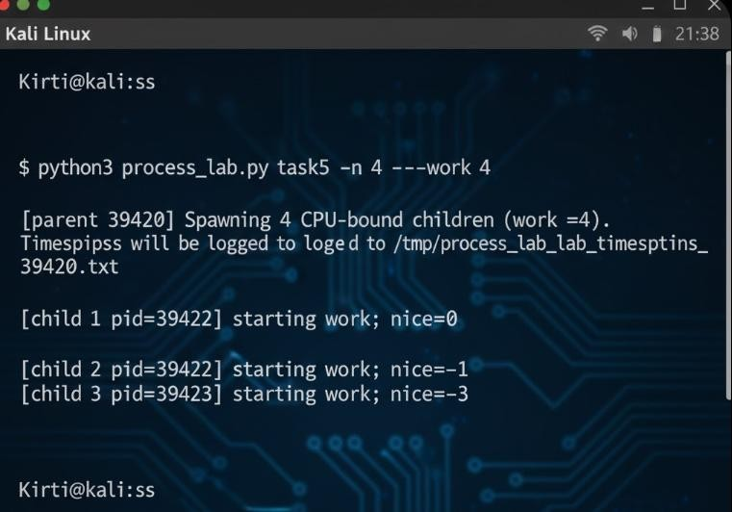

Lab Sheet Assignment -2

import multiprocessing import time
import logging

Sub-Task 1: Initialize the logging configuration

Objective: Set up the logging system to log messages with timestamps and process names.

logging.basicConfig( filename='process_log.txt', level=logging.INFO, format='%(asctime)s - %(processName)s - %(message)s'
)

Sub-Task 2: Define a function that simulates a process task (e.g., sleep for 2 seconds).

def system_process(task_name): logging.info(f"{task_name} started") time.sleep(2) # simulate work
logging.info(f"{task_name} ended")

Sub-Task 3: Create at least two processes and start them concurrently.

Sub-Task 4: Ensure proper termination and joining of processes, and verify the output in the log file.

if name == " main ":
print("System Starting...")

# Create two processes p1 = multiprocessing.Process(target=system_process, args=("Process-1",)) p2 = multiprocessing.Process(target=system_process, args=("Process-2",)) # Start both p1.start() p2.start()

# Wait for them to finish p1.join()
p2.join()

print("System Shutdown.")
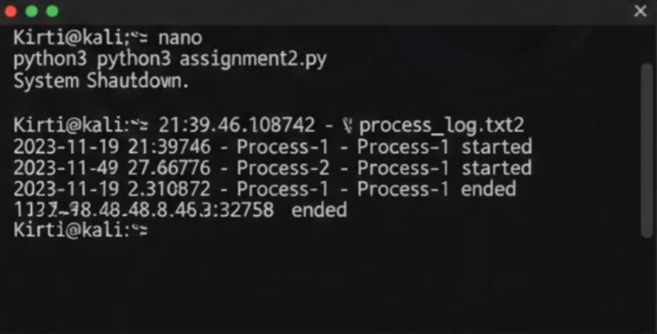

Lab Sheet Assignment -3
Task 1: CPU Scheduling with Gantt Chart

Write a Python program to simulate Priority and Round Robin scheduling algorithms. Compute average waiting and turnaround times. import math
def priority_scheduling():
print("\n=== PRIORITY SCHEDULING ===")
processes = []
n = int(input("Enter number of processes: "))

for i in range(n):
bt = int(input(f"Enter Burst Time for P{i+1}: ")) pr = int(input(f"Enter Priority (lower = higher priority) for P{i+1}: ")) processes.append((i + 1, bt, pr))

processes.sort(key=lambda x: x[2]) # Sort by priority (low → high) wt = 0 total_wt = 0 total_tat = 0 print("\nPID\tBT\tPriority\tWT\tTAT") for pid, bt, pr in processes:
tat = wt + bt print(f"{pid}\t{bt}\t{pr}\t\t{wt}\t{tat}") total_wt += wt total_tat += tat wt += bt

print(f"\nAverage Waiting Time: {total_wt / n:.2f}") print(f"Average Turnaround Time: {total_tat / n:.2f}")
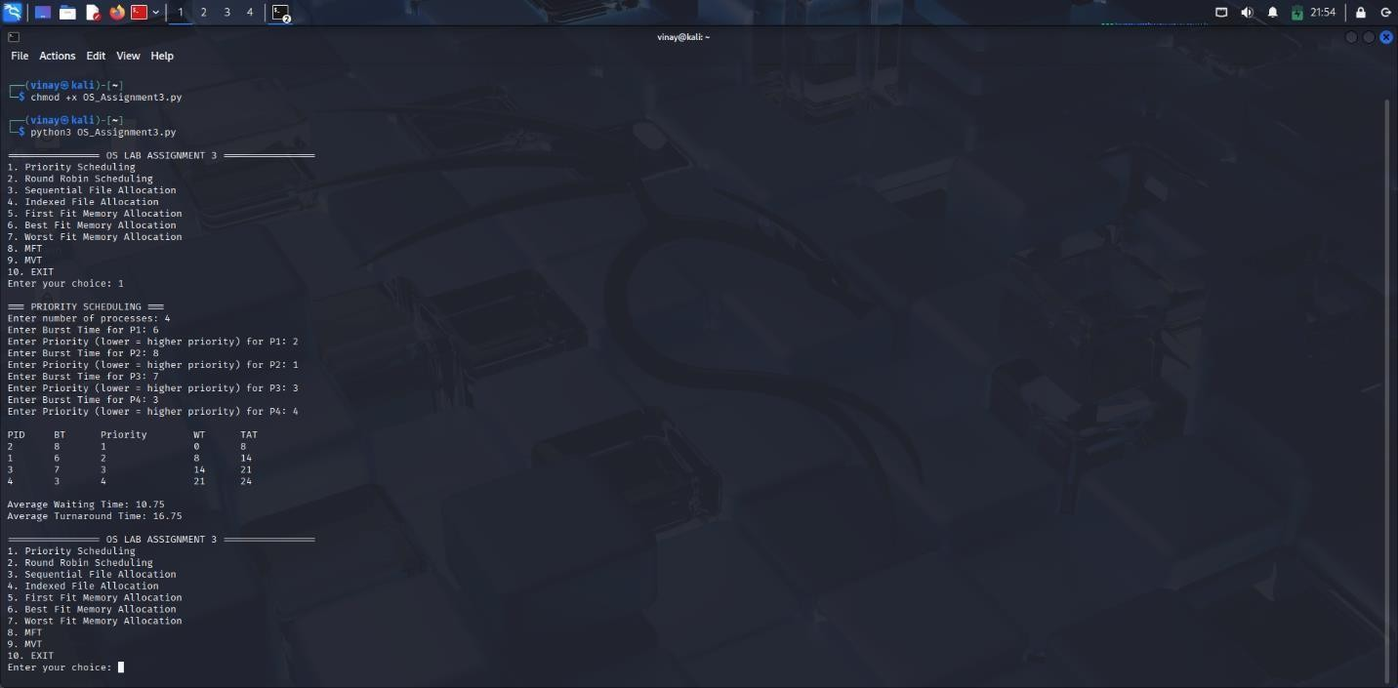

Round Robin def round_robin():
print("\n=== ROUND ROBIN SCHEDULING ===")

n = int(input("Enter number of processes: ")) burst_times = [] for i in range(n):
bt = int(input(f"Enter Burst Time of P{i+1}: ")) burst_times.append(bt)
quantum = int(input("Enter Time Quantum: "))

rem_bt = burst_times.copy() wt = [0] * n
t = 0 # current time

while True: done = True for i in range(n): if rem_bt[i] > 0: done = False if rem_bt[i] > quantum: t += quantum rem_bt[i] -= quantum
else:
t += rem_bt[i] wt[i] = t - burst_times[i]
rem_bt[i] = 0

if done:
break

tat = [burst_times[i] + wt[i] for i in range(n)]

print("\nPID\tBT\tWT\tTAT")
for i in range(n):
print(f"{i+1}\t{burst_times[i]}\t{wt[i]}\t{tat[i]}")

print(f"\nAverage Waiting Time: {sum(wt)/n:.2f}")
print(f"Average Turnaround Time: {sum(tat)/n:.2f}")

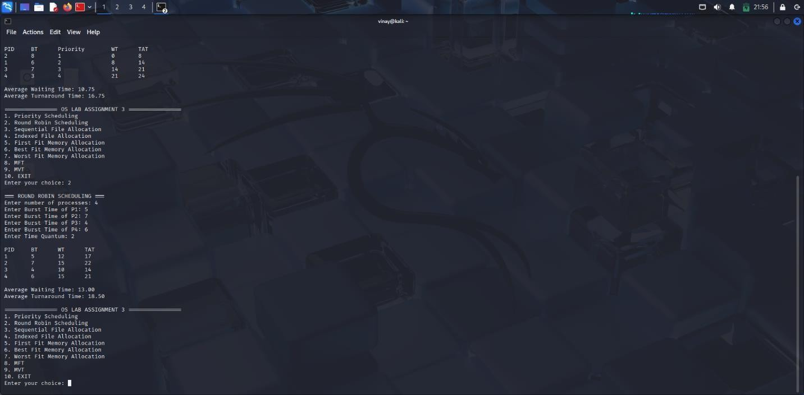

Task 2: Sequential File Allocation
Write a Python program to simulate sequential file allocation strategy.

def sequential_allocation():
print("\n=== SEQUENTIAL FILE ALLOCATION ===")

total_blocks = int(input("Enter total number of blocks: ")) block_status = [0] * total_blocks

n = int(input("Enter number of files: ")) for i in range(n):
start = int(input(f"Enter starting block for file {i+1}: ")) length = int(input(f"Enter length of file {i+1}: "))

allocated = True for j in range(start, start + length):
if j >= total_blocks or block_status[j] == 1:
allocated = False
break

if allocated:
for j in range(start, start + length):
block_status[j] = 1 print(f"File {i+1} allocated from block {start} to {start + length - 1}") else:
print(f"File {i+1} cannot be allocated.")

Task 3: Indexed File Allocation

Write a Python program to simulate indexed file allocation strategy.

def indexed_allocation():
print("\n=== INDEXED FILE ALLOCATION ===")

total_blocks = int(input("Enter total number of blocks: ")) block_status = [0] * total_blocks

n = int(input("Enter number of files: "))

for i in range(n):
index = int(input(f"Enter index block for file {i+1}: "))

if block_status[index] == 1:
print("Index block already allocated.") continue
count = int(input("Enter number of data blocks: "))
data_blocks = list(map(int, input("Enter block numbers: ").split()))

if len(data_blocks) != count or any(block_status[b] == 1 for b in data_blocks):
print("Invalid or already allocated block(s).")
continue

block_status[index] = 1 for b in data_blocks:
block_status[b] = 1
print(f"File {i+1} allocated → Index: {index} Data: {data_blocks}")

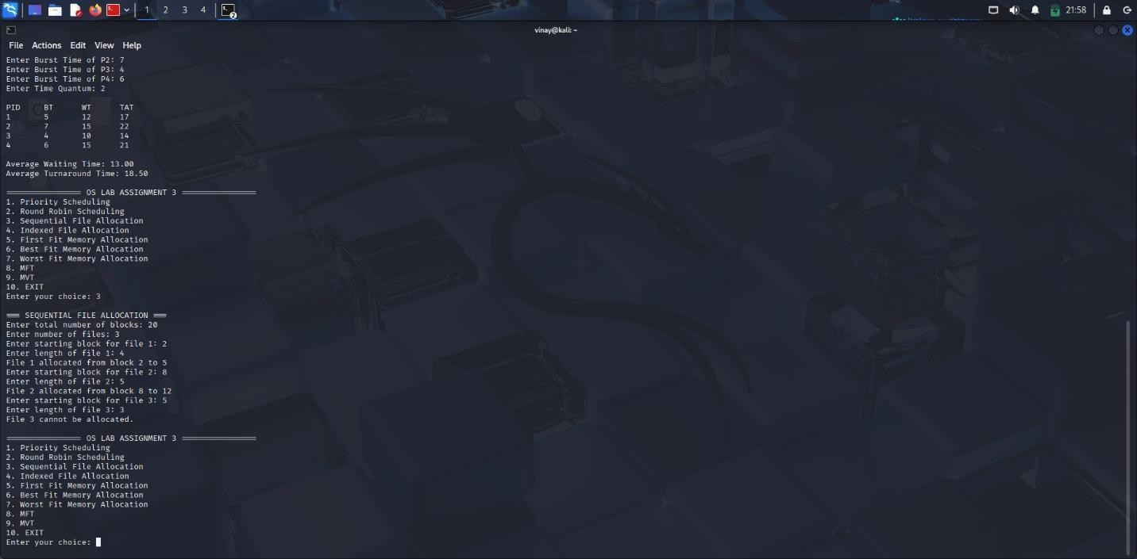
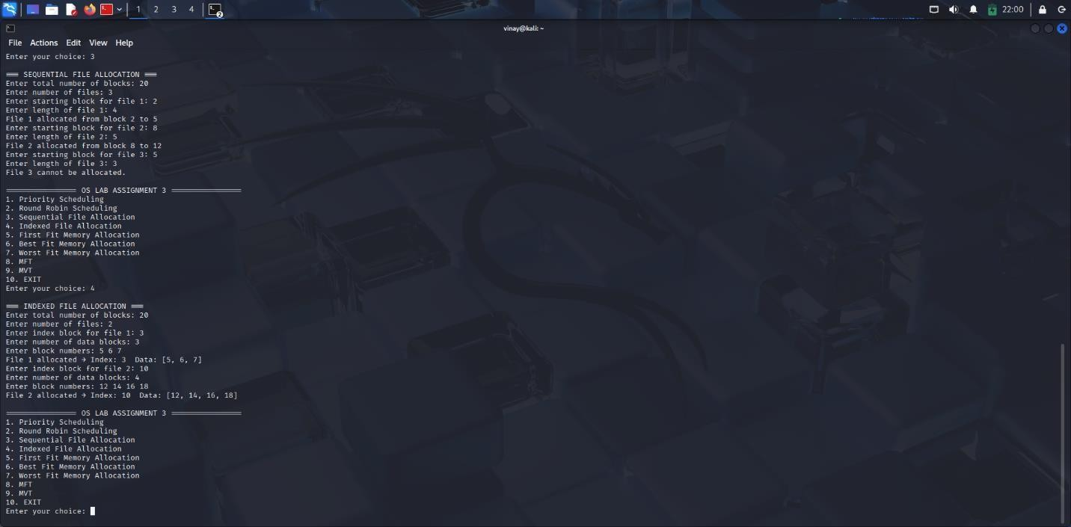

Task 4: Contiguous Memory Allocation
Simulate Worst-fit, Best-fit, and First-fit memory allocation strategies.

def allocate_memory(strategy):
print(f"\n=== {strategy.upper()} FIT MEMORY ALLOCATION ===")
partitions = list(map(int, input("Enter partition sizes: ").split())) processes = list(map(int, input("Enter process sizes: ").split())) allocation = [-1] * len(processes)
for i, psize in enumerate(processes): idx = -1

if strategy == "first": for j, part in enumerate(partitions):
if part >= psize:
idx = j
break
elif strategy == "best": best = float("inf") for j, part in enumerate(partitions):
if part >= psize and part < best:
best = part
idx = j
elif strategy == "worst":
worst = -1 for j, part in enumerate(partitions):
if part >= psize and part > worst:
worst = part
idx = j

if idx != -1:
allocation[i] = idx
partitions[idx] -= psize

for i, a in enumerate(allocation):
if a != -1: print(f"Process {i+1} allocated in Partition {a+1}") else:
print(f"Process {i+1} cannot be allocated")

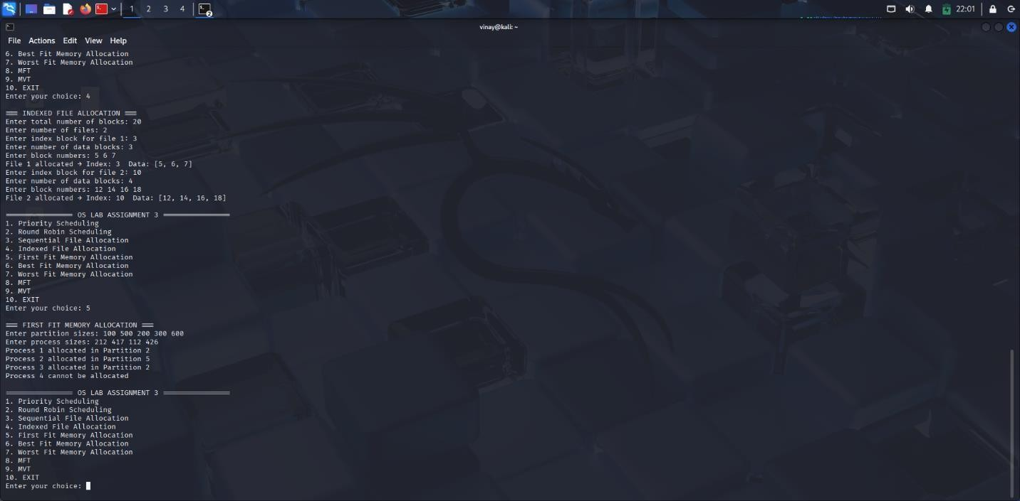
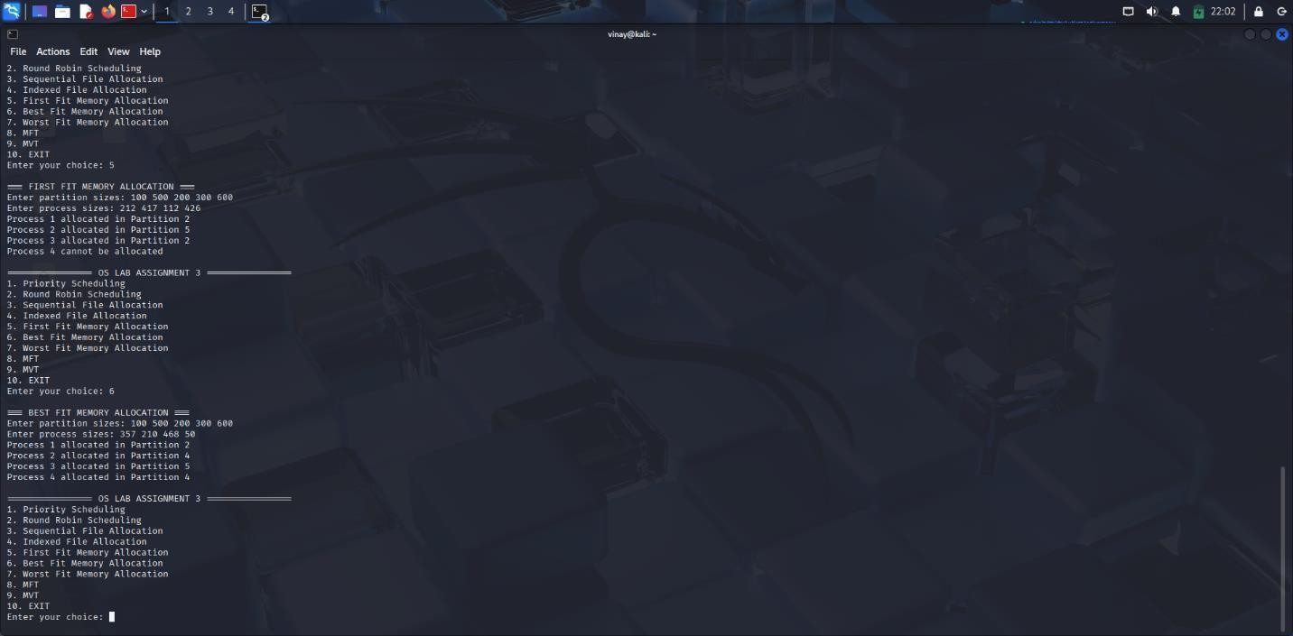

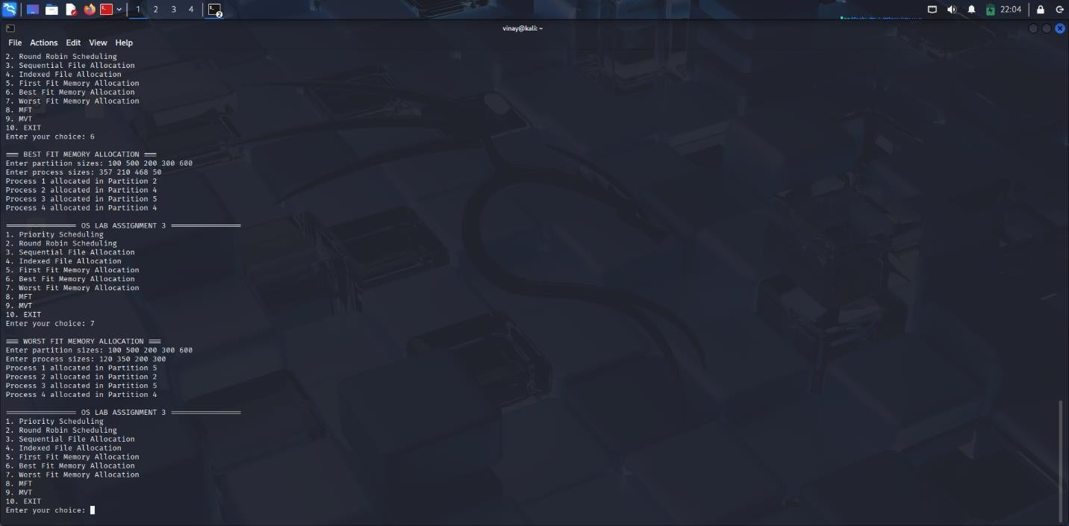

Task 5: MFT & MVT Memory Management
Implement MFT (fixed partitions) and MVT (variable partitions) strategies in Python.

def MFT():
print("\n=== MFT MEMORY MANAGEMENT ===")

mem_size = int(input("Enter total memory size: ")) part_size = int(input("Enter partition size: "))
n = int(input("Enter number of processes: "))

partitions = mem_size // part_size
print(f"Memory divided into {partitions} partitions")

for i in range(n):
psize = int(input(f"Enter size of Process {i+1}: ")) if psize <= part_size:
print(f"Process {i+1} allocated.") else:
print(f"Process {i+1} too large. Not allocated.")

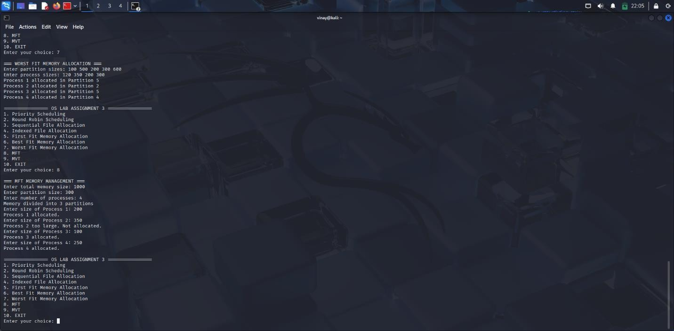

def MVT():
print("\n=== MVT MEMORY MANAGEMENT ===")

mem_size = int(input("Enter total memory size: "))
n = int(input("Enter number of processes: "))

for i in range(n):
psize = int(input(f"Enter size of Process {i+1}: ")) if psize <= mem_size: print(f"Process {i+1} allocated.") mem_size -= psize
else:
print(f"Process {i+1} cannot be allocated. Not enough memory.")

# ================================================================
# MAIN MENU
# ================================================================

def main():
while True:
print("\n================ OS LAB ASSIGNMENT 3 ================")
print("1. Priority Scheduling") print("2. Round Robin Scheduling") print("3. Sequential File Allocation") print("4. Indexed File Allocation") print("5. First Fit Memory Allocation") print("6. Best Fit Memory Allocation") print("7. Worst Fit Memory Allocation") print("8. MFT") print("9. MVT")
print("10. EXIT")

choice = int(input("Enter your choice: "))

if choice == 1: priority_scheduling() elif choice == 2: round_robin()
elif choice == 3: sequential_allocation() elif choice == 4:
indexed_allocation() elif choice == 5: allocate_memory("first") elif choice == 6: allocate_memory("best") elif choice == 7: allocate_memory("worst") elif choice == 8:
MFT()
elif choice == 9:
MVT()
elif choice == 10: print("Exiting...") break else:
print("Invalid choice. Try again.")

if name == " main ":
main()
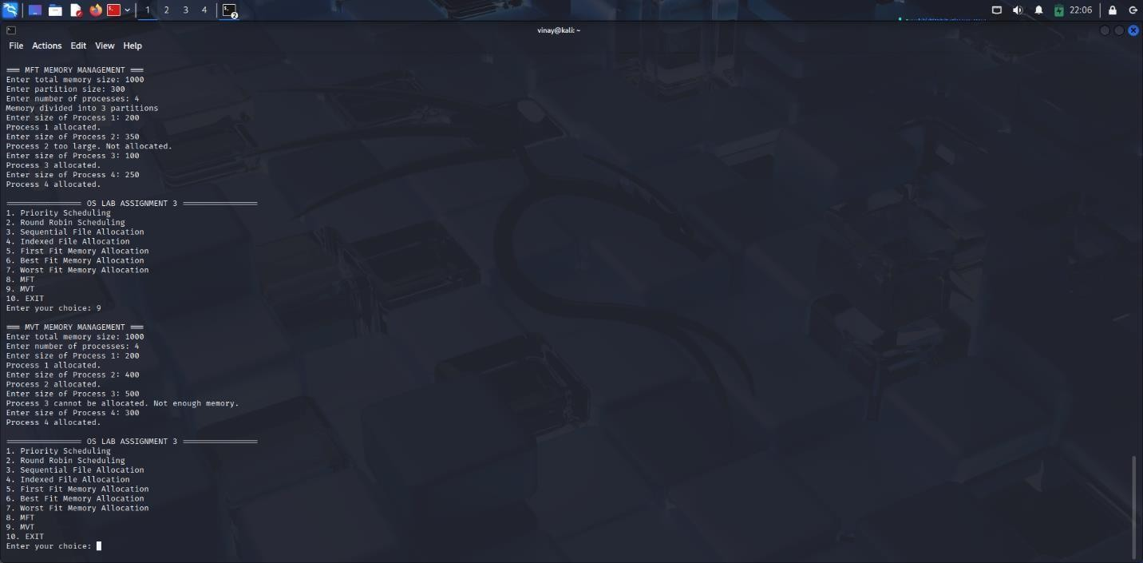
Lab Sheet Assignment -4

Task 1: Batch Processing Simulation (Python)
Write a Python script to execute multiple .py files sequentially, mimicking batch processing.

import subprocess
# List of Python scripts to execute sequentially scripts = ['script1.py', 'script2.py', 'script3.py']
print("=== Batch Processing Started ===") for script in scripts:
print(f"Executing {script}...") subprocess.call(['python3', script]) print("=== Batch Processing Finished ===")import multiprocessing import logging
import time

logging.basicConfig( filename='system_log.txt', level=logging.INFO, format='%(asctime)s - %(processName)s - %(message)s'
)

def process_task(name):
logging.info(f"{name} started") time.sleep(2)
logging.info(f"{name} terminated")

if name == ' main ': print("System Booting...") p1 = multiprocessing.Process(target=process_task, args=("Process-1",)) p2 = multiprocessing.Process(target=process_task, args=("Process-2",)) p1.start()
p2.start() p1.join() p2.join()
print("System Shutdown.")

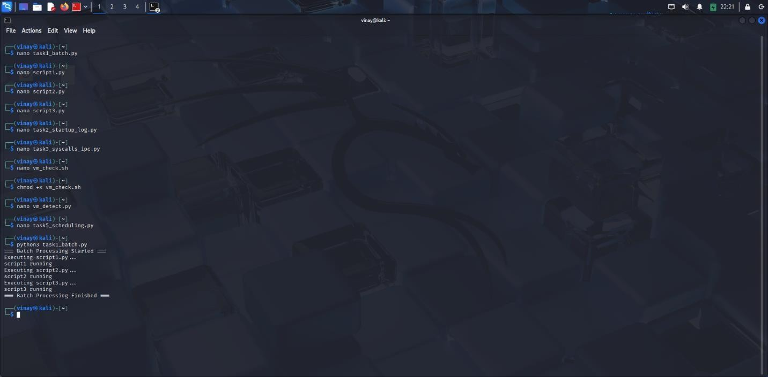

Task 2: System Startup and Logging
Simulate system startup using Python by creating multiple processes and logging their start and end into a log file.

import multiprocessing import logging import time logging.basicConfig( filename='system_log.txt', level=logging.INFO, format='%(asctime)s - %(processName)s - %(message)s'
)

def process_task(name):
logging.info(f"{name} started") time.sleep(2) logging.info(f"{name} terminated")

if name == ' main ': print("System Booting...") p1 = multiprocessing.Process(target=process_task, args=("Process-1",)) p2 = multiprocessing.Process(target=process_task, args=("Process-2",)) p1.start() p2.start() p1.join() p2.join()
print("System Shutdown.")



Task 3: System Calls and IPC (Python - fork, exec, pipe)
Use system calls (fork(), exec(), wait()) and implement basic Inter-Process Communication using pipes in C or Python.

import os r, w = os.pipe() pid = os.fork() if pid > 0: os.close(r) os.write(w, b"Hello from parent process!") os.close(w)
os.wait()
else:
os.close(w) msg = os.read(r, 1024) print("Child received:", msg.decode())
os.close(r)



Task 4: VM Detection and Shell Interaction
Create a shell script to print system details and a Python script to detect if the system is running inside a virtual machine.
#!/bin/bash echo "=== System Information ===" echo "Kernel Version:" uname -r echo "User:" whoami
echo "Hardware Virtualization:"
lscpu | grep -E "Virtualization|Hypervisor" echo "VM Detect (systemd-detect-virt):" systemd-detect-virt import subprocess
try:
out = subprocess.check_output("systemd-detect-virt", shell=True) result = out.decode().strip() print("VM Detection:", result) except:
print("Could not run systemd-detect-virt.")

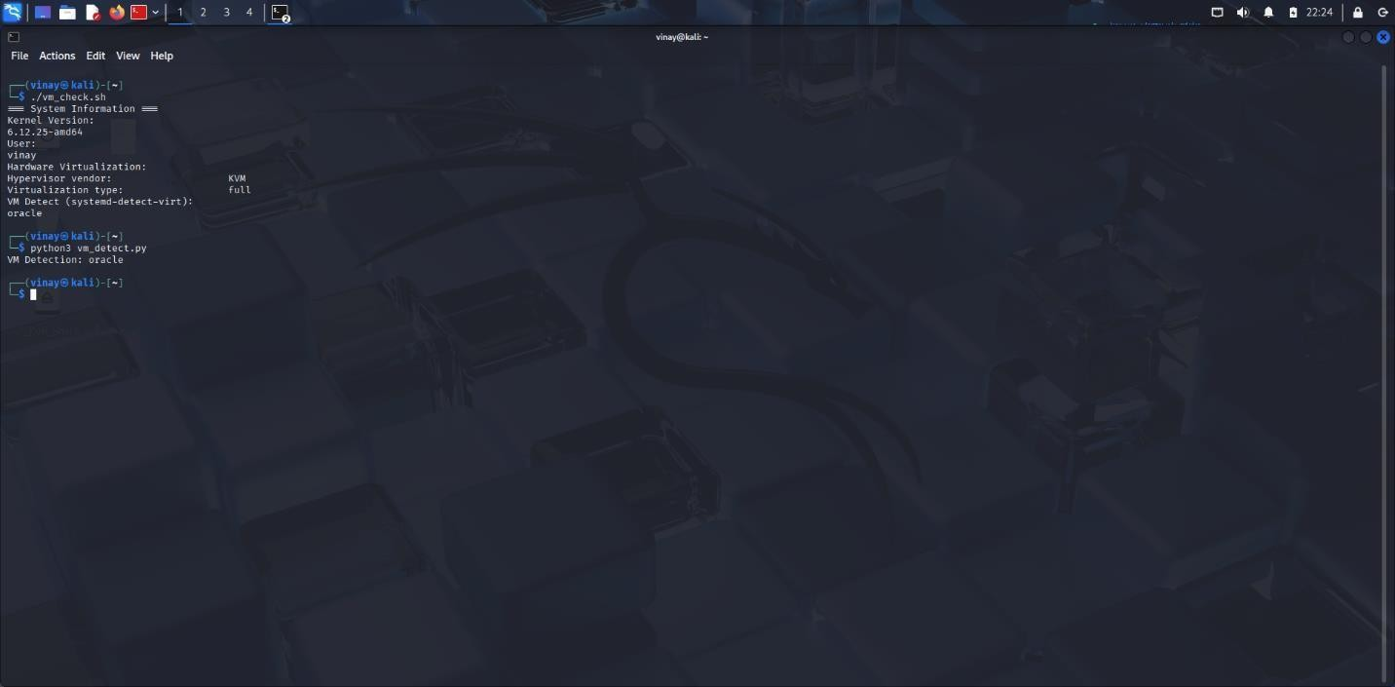

Task 5: CPU Scheduling Algorithms
Implement FCFS, SJF, Round Robin, and Priority Scheduling algorithms in Python to calculate WT and TAT.

def fcfs(processes):
print("\n=== FCFS ===") wt = 0 print("PID BT WT TAT") for pid, bt in processes: tat = wt + bt print(pid, bt, wt, tat) wt += bt def sjf(processes): print("\n=== SJF ===") procs = sorted(processes, key=lambda x: x[1]) wt = 0 print("PID BT WT TAT")
for pid, bt in procs: tat = wt + bt print(pid, bt, wt, tat) wt += bt def priority(processes): print("\n=== PRIORITY ===") procs = sorted(processes, key=lambda x: x[2]) wt = 0 print("PID BT PR WT TAT")
for pid, bt, pr in procs: tat = wt + bt print(pid, bt, pr, wt, tat)
wt += bt def round_robin(processes, q): print("\n=== ROUND ROBIN ===")
bt = [p[1] for p in processes] rem = bt.copy() n = len(bt) wt = [0]*n
t = 0
while True: finished = True for i in range(n):
if rem[i] > 0: finished = False if rem[i] > q: t += q rem[i] -= q else:
t += rem[i] wt[i] = t - bt[i]
rem[i] = 0 if finished:
break print("PID BT WT TAT")
for i in range(n):
print(processes[i][0], bt[i], wt[i], bt[i]+wt[i])

if name == " main ":
fcfs([(1,5),(2,3),(3,8),(4,6)]) sjf([(1,6),(2,2),(3,8),(4,3)]) priority([(1,6,2),(2,4,1),(3,5,3)])
round_robin([(1,5),(2,7),(3,4)], q=2)

